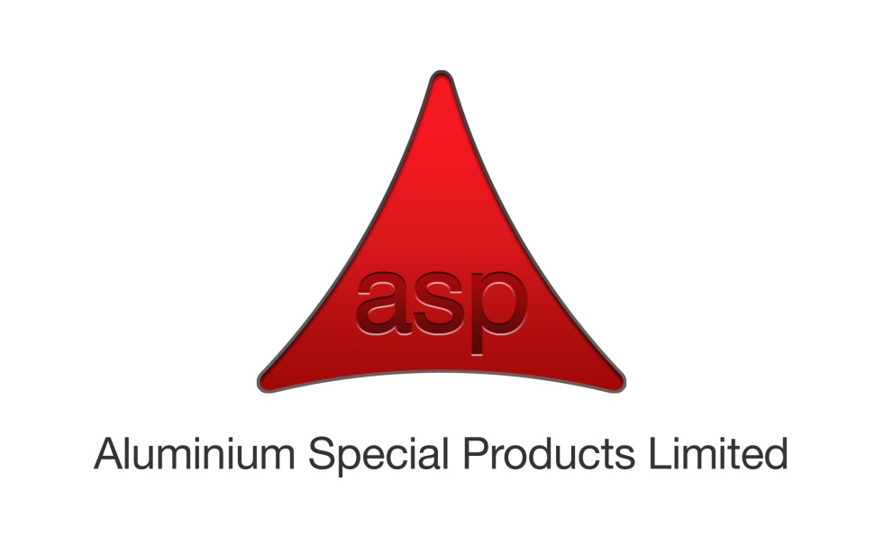

**ENVIRONMENTAL POLICY STATEMENT.**

***Management and staff at Aluminium Special Products regard the promotion and preservation of the environment as a mutual objective for Management and employees at all levels.***

We are fully committed to protecting and continually improving the quality of our working and local environments. We are committed to working pro-actively with, and communicating this policy to our employees, clients, contractors and all other external interested parties to achieve a safer, cleaner, healthier and sustainable environment. This will fulfil present and future human and legislative needs.

The objectives of this policy are to:

* Reduce the production of waste and encourage wherever possible it’s re-use or re-cycling.
* Encourage greater staff involvement through environmental awareness training, the understanding of environmental issues and continual environmental improvements.
* Minimising energy usage by involving all members of staff in energy conservation initiatives.
* Ensuring openness of our environmental activities with all stakeholders including employees, customers, suppliers and regulators.
* Evaluate environmental impacts when considering new products, plant, equipment, buildings and processes.
* Prevent pollution and nuisance and ensure minimum impact on our customers and neighbours.
* Manage the correct, safe and effective disposal of waste materials and products through approved and qualified agencies/providers.
* Encourage the sustainable purchasing of plant and equipment giving due consideration to their environmental impacts i.e. energy efficiency, emissions / pollution prevention and disposal at end of its life cycle.

ASP are committed to the continual improvement of our QEMS that supports the enhancement of our environmental performance and complying with environmental laws, regulations and other requirements relevant to our business.

We will provide adequate resources and closely monitor our business processes to ensure that the company’s operations and opportunities are effectively managed and risks mitigated in accordance with the requirements of BS EN ISO 9001:2015, BS EN 9100:2016 and BS EN ISO 14001:2015.

This policy will be communicated to all employees and when requested, stakeholders and or interested parties via ASP web site; <http://www.aspgroup.co.uk/company/accreditations/>

The Managing Director and Management Team will demonstrate leadership and commitment through the implementation of the QEMS, including the review of this policy and formulation of QEMS objectives during management reviews to ensure its integrity, effectiveness and compatibility with the context and strategic direction of the organisation.

**Signed:**



**David Robinson**

**Managing Director**

**1st March 2018.**

