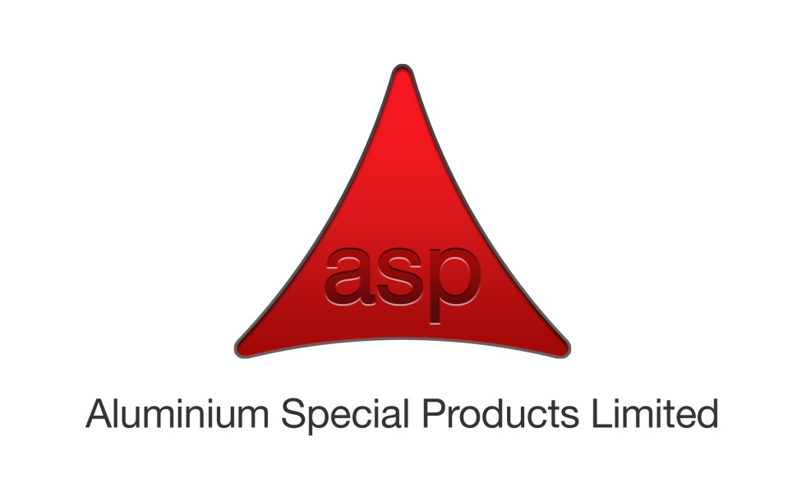

**Quality Policy Statement.**

***Management and staff at Aluminium Special Products are dedicated to the principle of never ending improvements in innovation, product quality, reliability and customer service excellence.***

ASP is an acknowledged industry expert in the supply of aluminium and aluminium alloy materials as well as downstream processing.

Virtually everything that we do has to achieve high performance in one way or another so we have to embrace the principals of continuous improvement in product innovation, quality, reliability and customer service.

Our principal aim is to always supply to our customer’s high quality, reliable products with unrivalled levels of customer service that conform exactly to stated, agreed specifications, order requirements and any other underpinning relevant statutory or regulatory requirements.

The establishment of our Quality Management System (QEMS) is therefore the foundation to establish a company culture committed to continual improvement.

Our QEMS is based on the requirements of BS EN ISO 9001:2015, BS EN 9100:2016 and BS EN ISO 14001:2015 and ASP are fully committed to fulfilling these and other pertinent agreed requirements. The system has been developed to enable full integration of in-house, product, industry best practice and client specific requirements.

Our QEMS provides a risk based approach to thinking, managing opportunities and mitigation of risks, including the elimination of product / service quality defects or other potential quality issues at the earliest stage possible. This in turn improves the overall efficiency of the organisation and supports with the achievement of the established quality objectives and customer satisfaction.

This policy will be communicated to all employees and when requested, stakeholders and or interested parties via ASP web site; <http://www.aspgroup.co.uk/company/accreditations>

The Managing Director and Management Team will demonstrate leadership and commitment through the implementation of the QEMS, including the review of this policy and formulation of QEMS objectives during management reviews to ensure its integrity, effectiveness and compatibility with the context and strategic direction of the organisation.

**Signed:**



**David Robinson**

**Managing Director**

**1st March 2018.**

